**NGUYỄN VIỆT TÂN - 102180225**

1. **UDP**

* 1. The UDP header contains 4 fields: source port, destination port, length, and checksum.

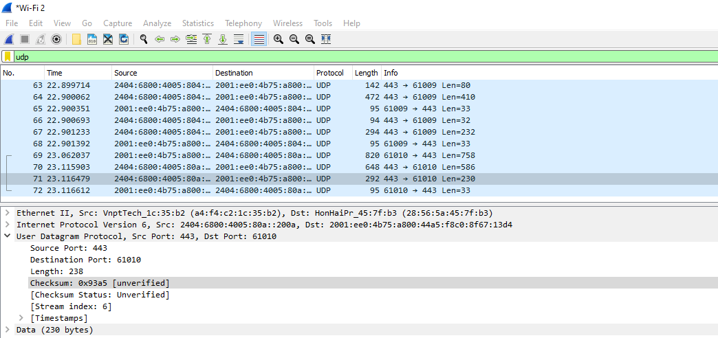

* 2. Each of the UDP header fields is 2 bytes long
* 3. The value in the length field is the sum of the 8 header bytes, plus the 230 encapsulated data bytes.

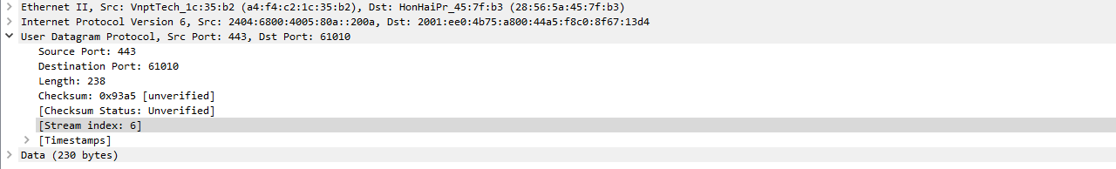

* 4. The maximum number of bytes that can be included in a UDP payload is 2^16 – 1 (bytes). This gives 65535 – 8 = 65527 bytes.
* 5. The largest possible source port number is 2^16 – 1 = 65535(port).
* 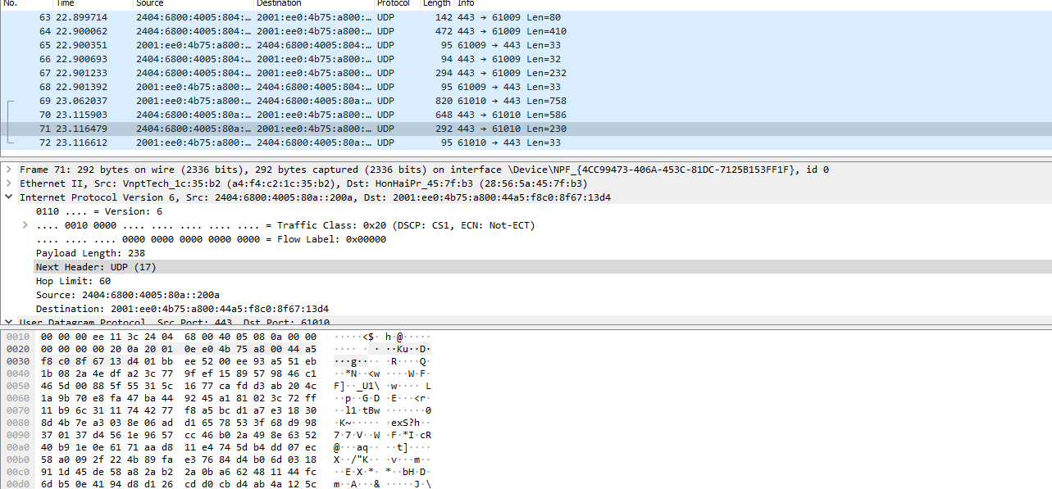
* 7. The source port of the UDP packet sent by the host is the same as the destination port of the reply packet, and conversely the destination port of the UDP packet sent by the host is the same as the source port of the reply packet.

**2.TCP**

1.IP address: 192.168.1.102

TCP port number: 1161

2.IP address: 128.119.245.12

TCP port: 80

3.

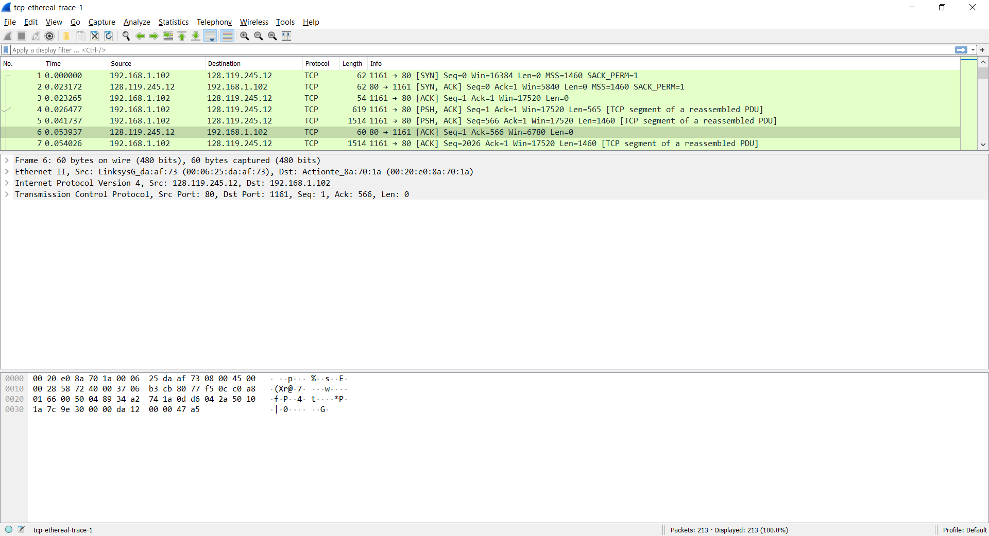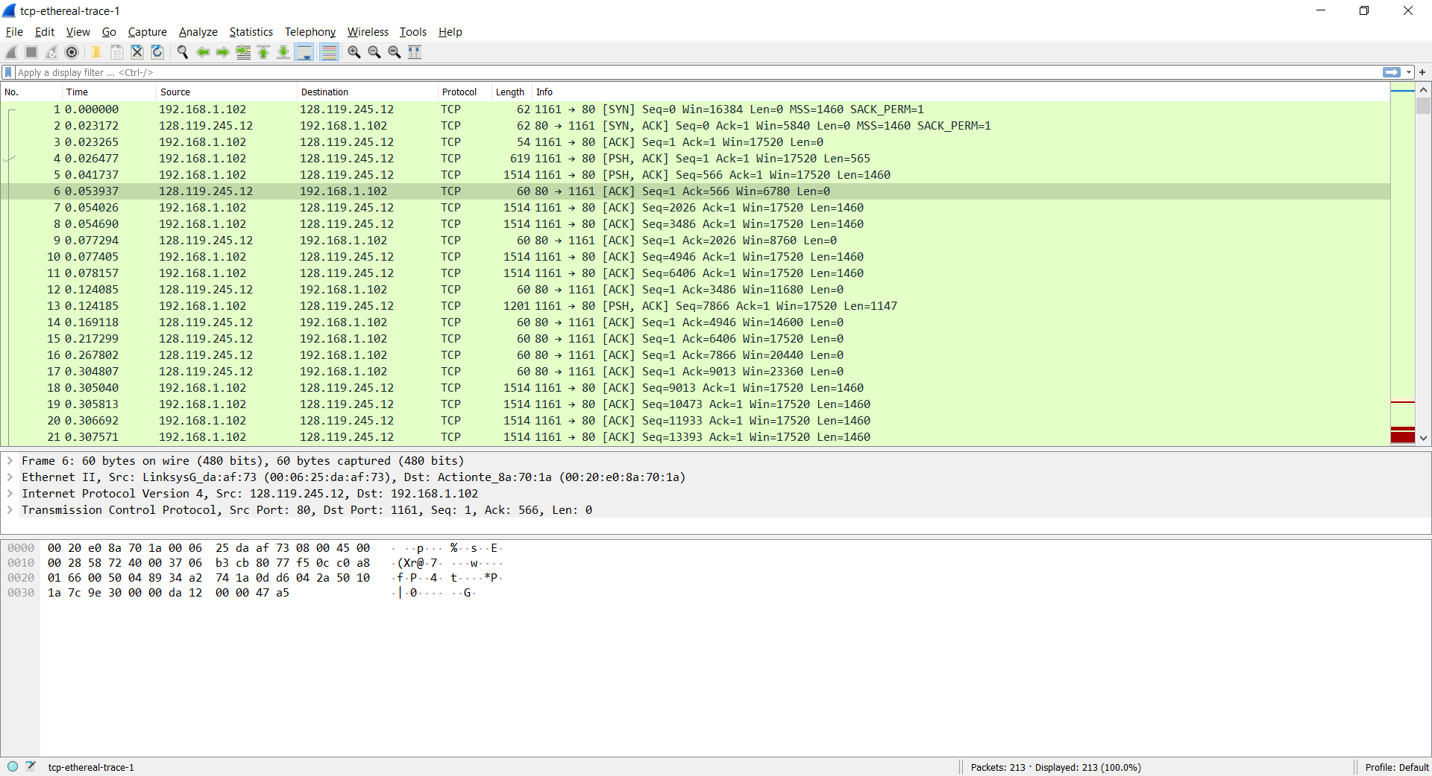4,5.

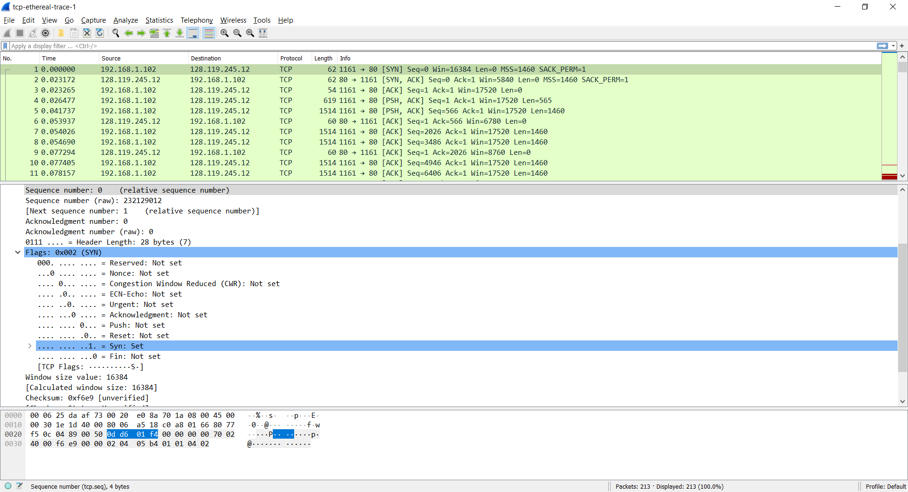Sequence number of the TCP SYN segment is used to initiate the TCP connection between the client computer and gaia.cs.umasss.edu. The value is 0 in this trace. The SYN flag is set to 1 and it indicates that this segment is a SYN segment.

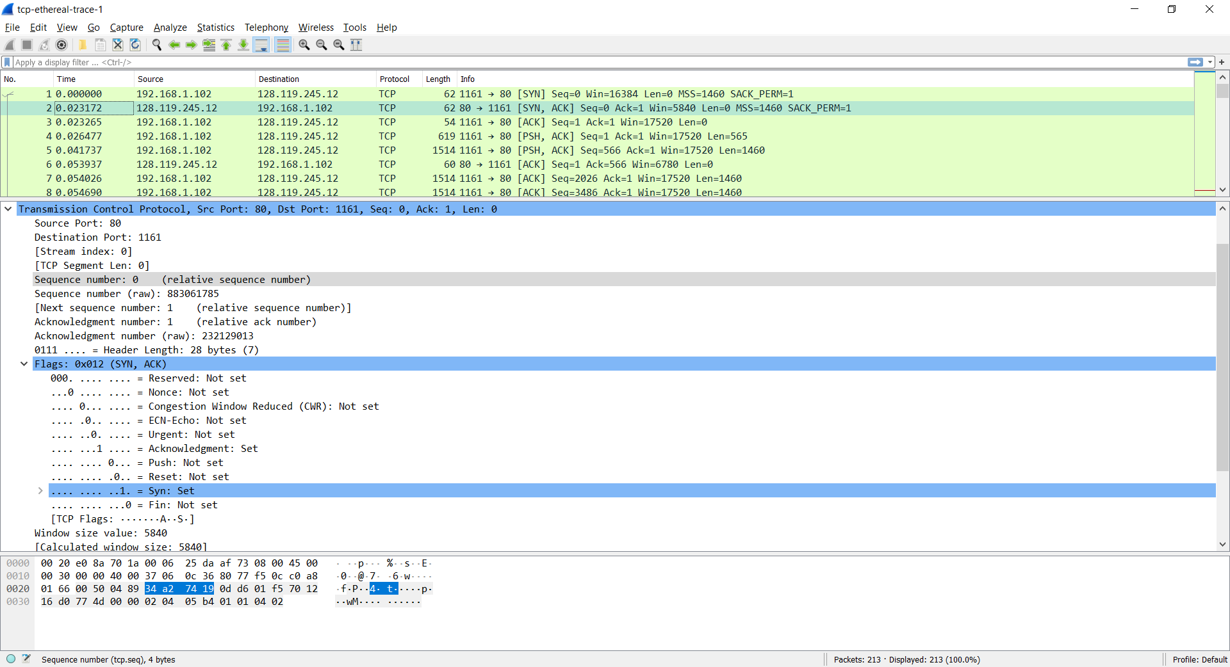6.

No.199 segment is the TCP segment containing the HTTP POST command. The sequence number of this segment has the value of 1.